Cyclone tracking map questions
Part A
- How is this map useful in helping to minimise the impact of a cyclone?
- Name the ABC station and frequency closest to your home.
- What should you do as a cyclone approaches? Complete the acronym.

T

L

L

A
- Where should you shelter if you stay in your home during a cyclone?
- Explain why the instructions state not to go outside during the calm eye of the cyclone. Use your science knowledge.
Part B
- What is the difference between emergency kits and evacuation kits?
- Why would these kits differ?
- Fill in the names of the missing items from the emergency kit in the table below. Explain why each item is important in the kit.
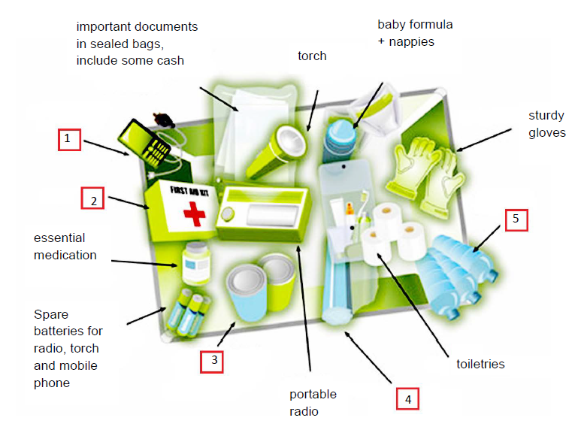
 | Item | Why is this item necessary in the kit?

1

2

3

4

5
Modified from: Cyclone Tracking Map (Emergency Management Queensland) CC BY-NC 3.0 creativecommons.org/licenses/by-nc/3.0/au/deed.en

